Hello Luis,

Thank you so much for your text. As mentioned, I need an estimate for cost and time for the development of a phone application prototype.

The application is very much inspired by Pokemon Go mixed with any streaming platform you can think of.

Essentially, the app shows video presentation based on the location of the phone user.

Here is intended summary of the experience of the user of the app:

1. Login on the platform (just like you would login any streaming platform – I personally like Netflix interface)
2. Video content in organized section by theme in their respective category (considering that we’re at the prototype stage, I just need the categories, and one video presentation)
3. The user selects the one video presentation
4. The user is directed to the closest point of the itinerary
5. Once the user is at the aforementioned designated point, she/he will be guided through an itinerary
6. A notification is sent to the user when the user arrives at a next designated point.
7. The user is then prompted to engaged a video at the designated point.
8. When finished, on to the next point.

I would like a prototype covering a small area/neighbourhood of the city I live in right now, Murcia and Montreal.

Here in image, more or less how I see the prototype

Logging page

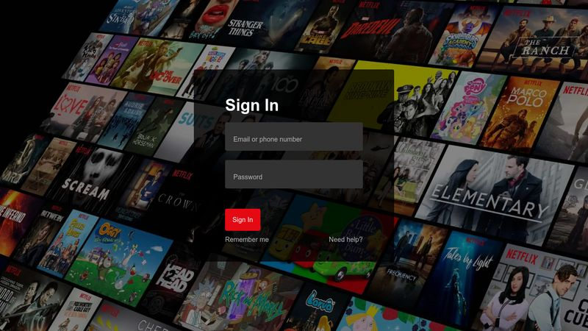

Platform menu of video category

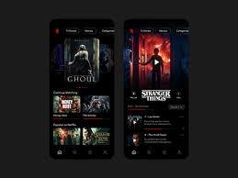

Map with the prompt to the closest designated point

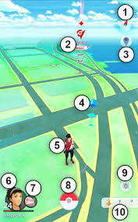

Notification once at the designated point if you walk to the area with phone shut

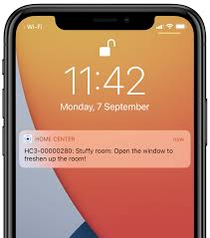

Video Launch with a presentation (instead of a pokemon, a person presenting the location)

